**Tutorial 30: Two-way Data Binding – Checkboxes**

We can use v-model with other form fields other than input boxes. We will be focusing on the checkboxes input field in this tutorial. There are two use v-models with checkboxes, one where we check whether the value is true or false and the other adds values in an array.

Make sure **Tutorial 28** is complete to be able to move on to this tutorial or clone the [vue3-firebase-course](https://github.com/younggrasshopperza/vue3-firebase-course) repository and go to branch called **Tutorial-28** and navigate to the web-form folder.

**Step 1:** In the **Signup.vue** file, inside the form tag, under the select tag, create a div with a class called terms. Inside the div, create an input tag with the type checkbox. Underneath, create a label and inside the label put the text, “**Accept Terms and Conditions**”.

Look at the example below (**Between line 17 and 20**):

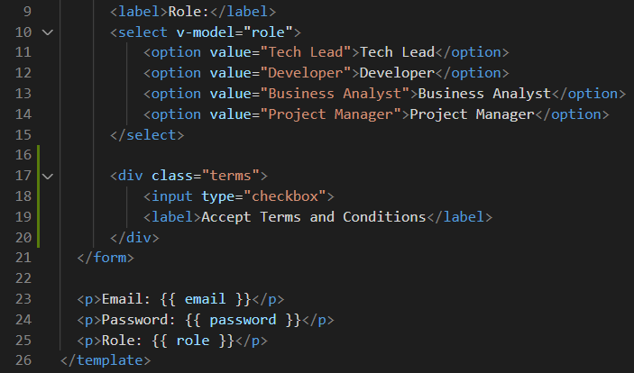

**Step 2:** In the **Signup.vue** file, style the checkbox by copying the following css code below:

input[type="checkbox"] {

    display: inline-block;

    width: 16px;

    margin: 0 10px 0 0;

    position: relative;

    top: 2px;

}

**Step 3:** In the **Signup.vue** file, create a data property called terms and give it a value of false. By default, when the checkbox is not ticked it is false but when the checkbox is ticked the value is true. If we want the value to be checked by default, then we would make the value true

Look at the example below (**Line 36**):

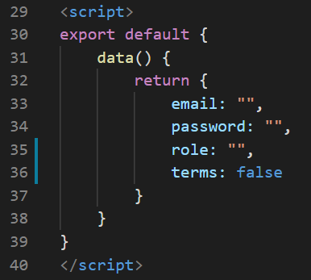

**Step 4:** In the **Signup.vue** file, inside the input with the type checkbox, create a v-model attribute with the value terms and output the value in a paragraph tag under the role.

Look at the example below (**Line 26**):

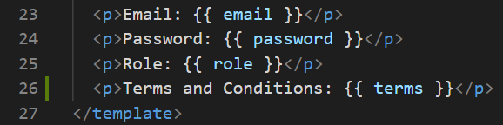

Another way to work with checkboxes is by using an array if values and multiple different checkboxes. We are going to give the user the ability to check multiple checkboxes and once the checkbox is checked the value will be stored in an array.

**Step 5:** In the **Signup.vue** file, create a data property called names that has a value of an empty array.

Look at the example below (**Line 50**):

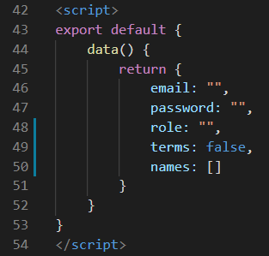

**Step 6:** In the **Signup.vue** file, under the div tag with the class terms, create a div tag and inside the div create an input with the type checkbox and give the input a v-model attribute with the value names. Create a label tag and give it someone’s name. Duplicate the div with checkbox and label, two more times and change the label names to have other names.

Look at the example below (**Between** **line 22 and 33**):

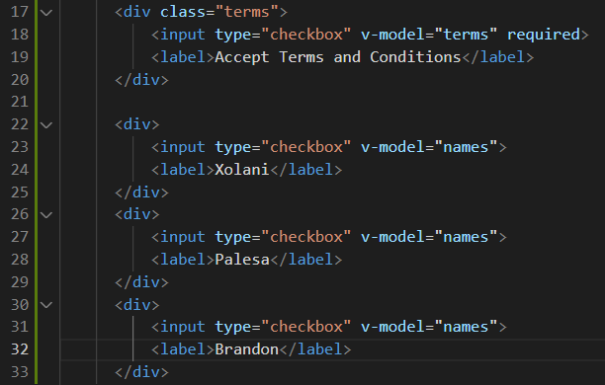

**Step 7:** In the **Signup.vue** file, include value attributes inside the newly created inputs and inside the values include the same values as the labels.

Look at the example below (**Line 23, line 27 and line 31**):

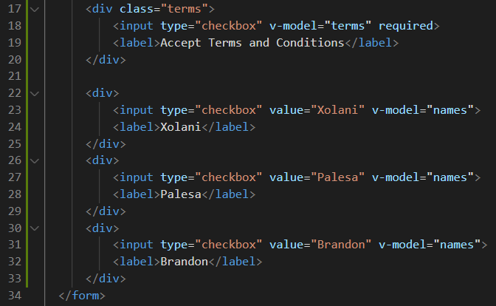

**Step 8:** In the **Signup.vue** file, include a paragraph tag that outputs the name data property under the terms and Conditions paragraph tag.

Look at the example below (**Line 23, line 27 and line 31**):

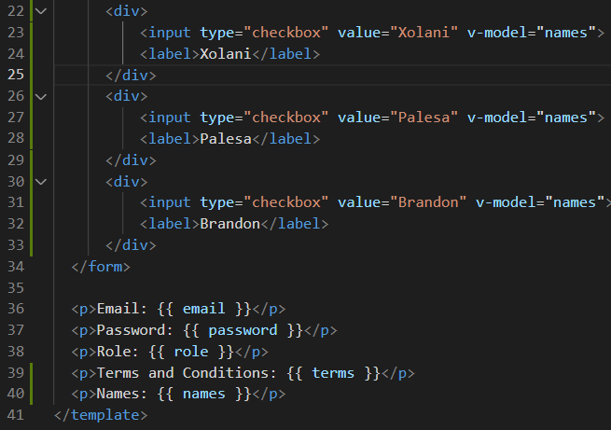

**Output:**

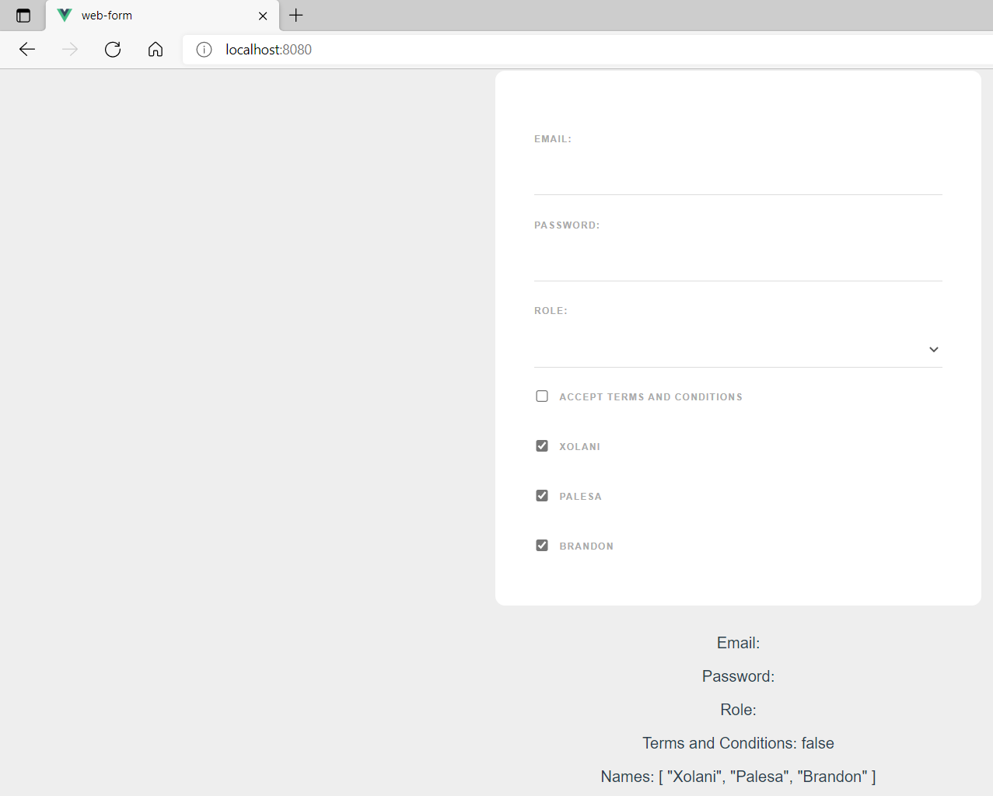

We can undo Steps 5 to 8. We were doing this for demonstration purposes. It does not contribute to the next tutorial we will be working on.

**You can view the code snippets from the** [**vue3-firebase-course**](https://github.com/younggrasshopperza/vue3-firebase-course) **repository under the Tutorial-30 branch**.